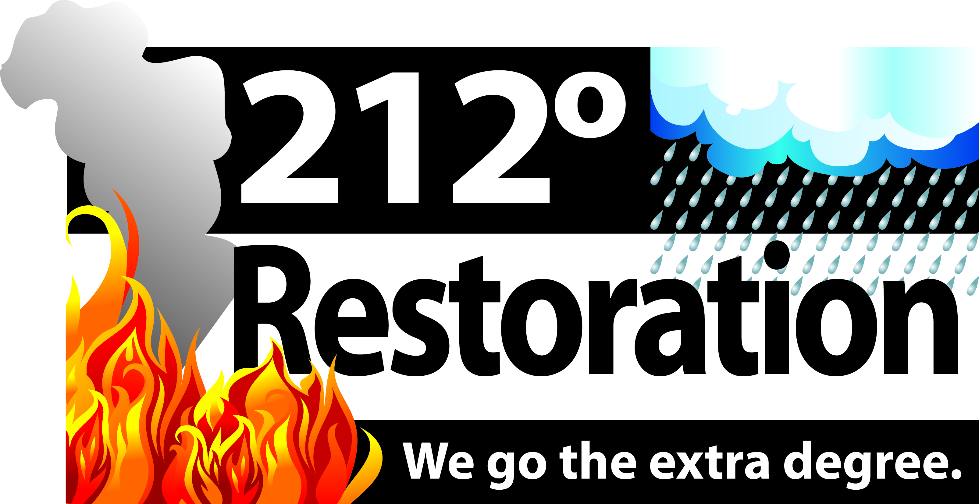

**Return registration by fax to:** (970) 797-6388 **Attn:** Stephen Lautzenhiser  **Phone:** (970) 231-0120

Name (as it appears on your Real Estate License): ___________________________________________________

Real Estate Company/Agency Name: ______________________________________________________________

Address: _________________________________________________________________________________________

City/ST/Zip: _______________________________________________________________________________________

Business Phone #: _________________________________________________________________________________

License Number: ___________________________________________________________________________________

Date of Birth: ______________________________________________________________________________________

E-mail Address: ____________________________________________________________________________________

REGISTRATION FORM (Fill out completely) PLEASE COMPLETE FORM NO LATER THAN 2/7/14

**Water Damage**

Course #: 3941

Credits: 3

**Presented by Stephen Lautzenhiser, Owner 212 Restoration**

**Date: Tues. Feb 11th Time: 11:45-4:00**

(Lunch included)

**Location: Moot House 2626 S College Ave (College and Drake) Fort Collins**

FREE OF CHARGE

Hosted by:

**212° Restoration- Stephen Lautzenhiser**

**CE CLASS**

**REGISTRATION**