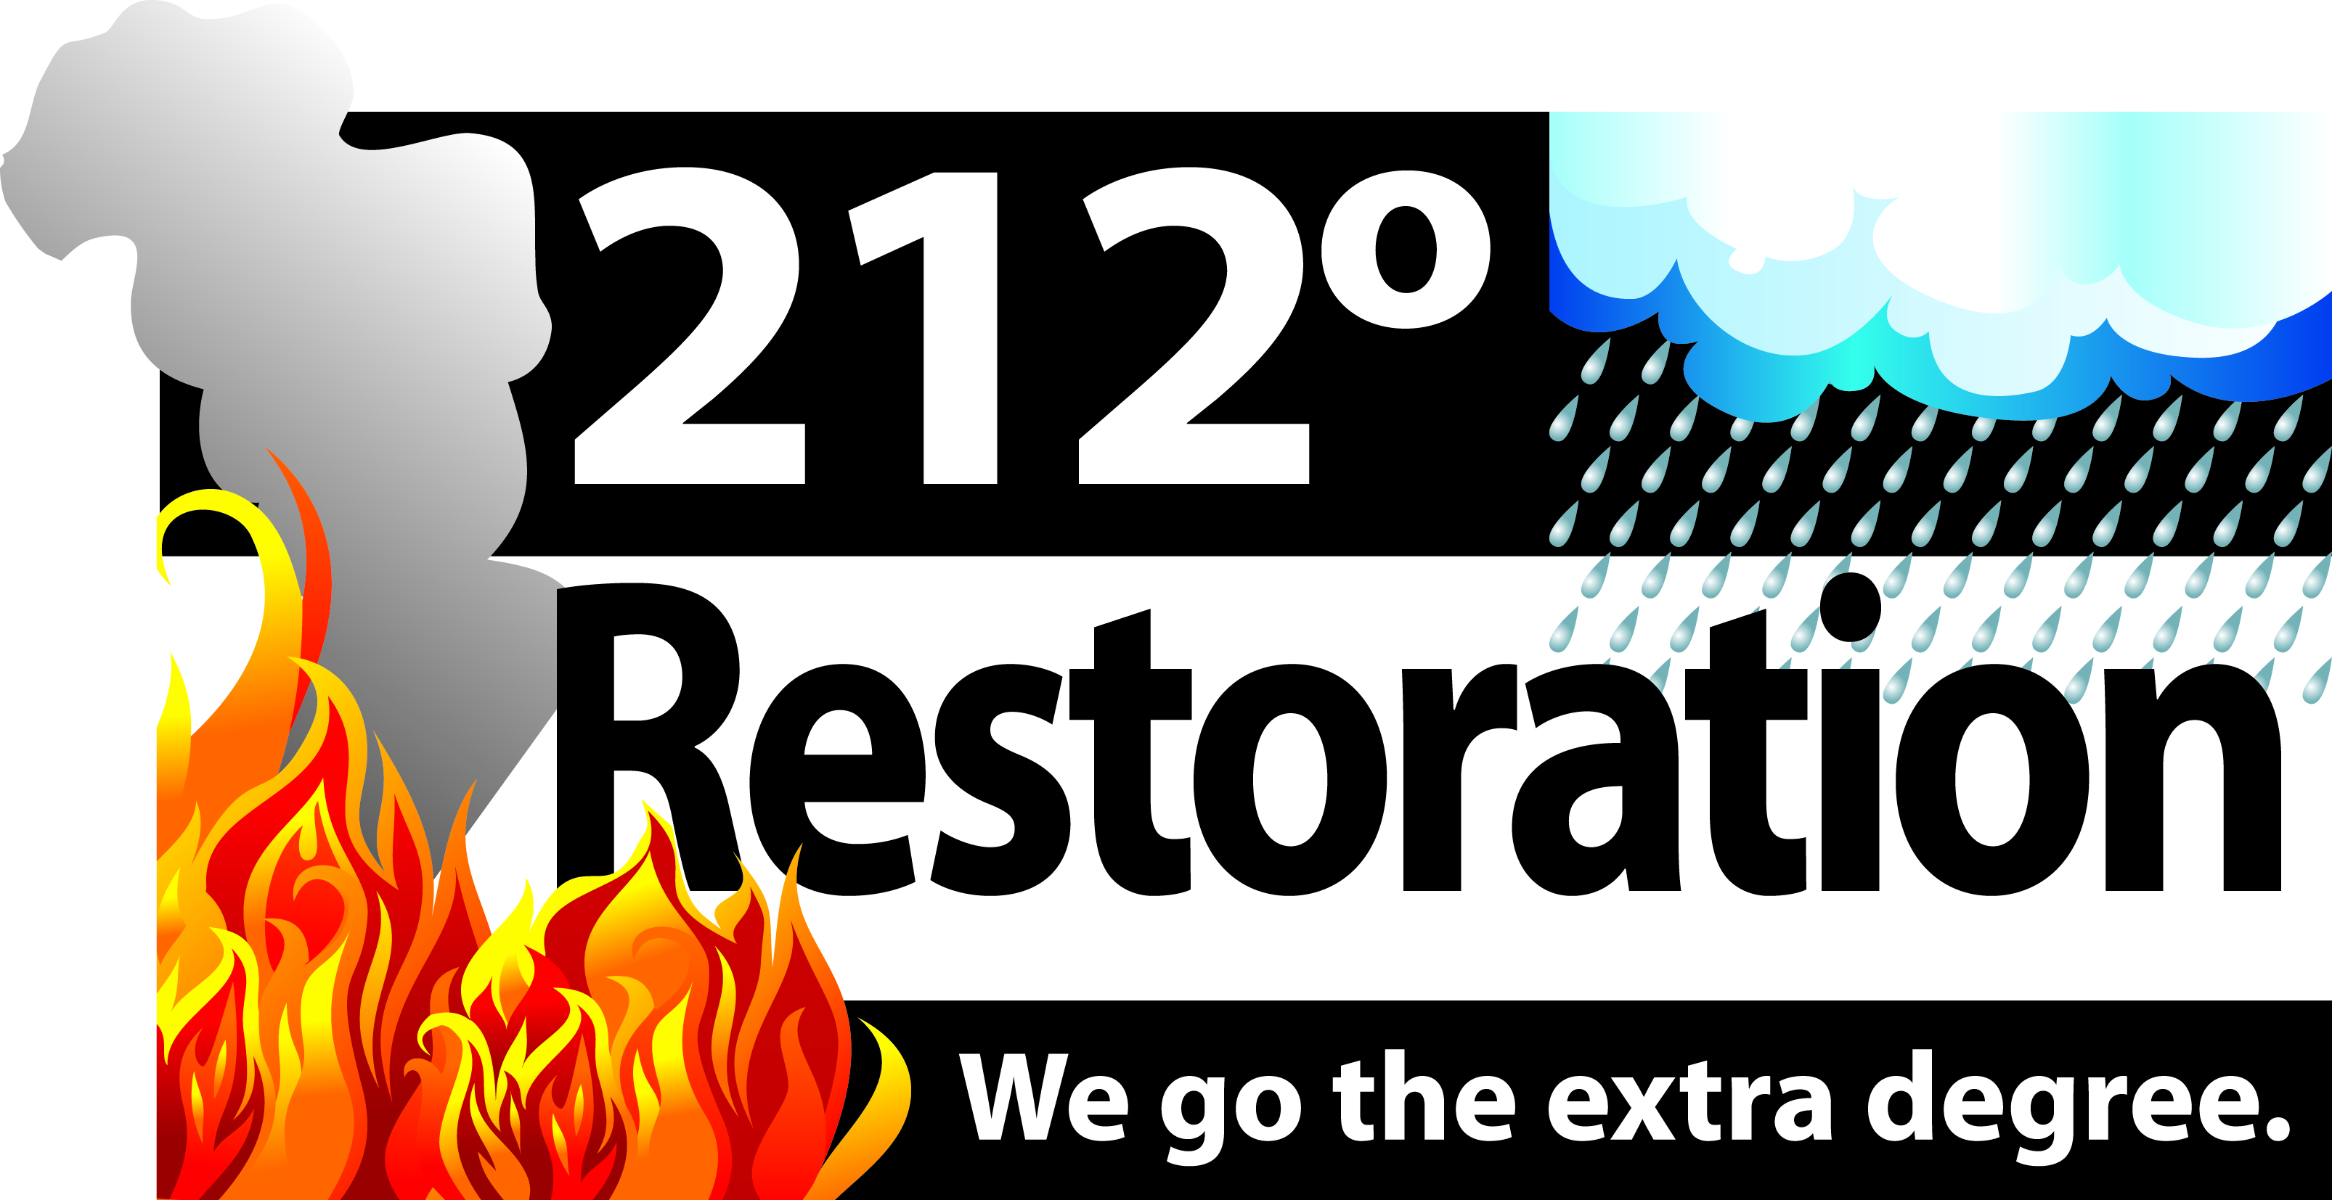 

**Water Damage Remediation**

Credits: 3

Course# Insurance 52693 Real Estate: 3941

Presented by a Certified Industry Professional

**Date: October 15, 2015 Time: 11:30-3:00**

**FREE LUNCH**

**Location: The Boot Bar and Grill: 4164 Clydesdale Pkwy Loveland (25 and Crossroads)**

Name (as it appears on your License): _______________________________________________

Real Estate Company/Insurance Agency Name:

Address: ____________________________________________________________________________

City/ST/Zip: _______________________________________________________________________________________

Business Phone #: _________________________________________________________________________________

Real Estate/Insurance License #:

Date of Birth: ______________________________________________________________________________________

E-mail Address: ____________________________________________________________________________________

REGISTRATION FORM (Fill out completely) PLEASE COMPLETE FORM NO LATER THAN 10/8/15

**Return registration by fax to:** (970) 797-6388 **Attn:** Leslie Lautzenhiser  **Phone:** (970) 980 1996

**Email:** leslie@212restoration.com

Hosted by:

**212° Restoration, National 1 Source Title and Escrow**

**and Northstar Bank and Mortgage**

**CE CLASS**

**REGISTRATION**

FREE OF CHARGE